Ecommerce Platform: Design Document
1. Project Overview
Build a full-stack ecommerce platform based on the use-case.

Core functionality will include:
Product catalogue
Search and filtering
Offers and clearance sale
Cart and ordering
Order tracking
Clone/reorder previous order
User profile
Wishlist
Wishlist notifications
Product comparison
Out-of-stock alternative recommendations
AI-assisted chatbot

2. Frontend
Language: JavaScript
Framework/Library: React
Build Tool: Vite
Package Manager: npm
Development Server: Vite dev server on localhost:5173
Styling: CSS initially; Tailwind CSS can be considered later if approved

Frontend responsibilities:
Render ecommerce pages and UI components
Display product catalogue, cart, wishlist, orders, notifications, comparison page and chatbot
Send API requests to Django backend
Handle user input, loading states and frontend validation

3. Backend
Language: Python
Framework: Django
API Framework: Django REST Framework
Development Server: Django development server on localhost:8000

Backend responsibilities:
Expose REST API endpoints for the frontend
Handle business logic
Manage product, order, wishlist, notification and chatbot-related data
Validate incoming requests
Connect to the database using Django ORM
Control access to data used by the chatbot

4. Database
Development Database: SQLite temporarily during setup
Target Database: MySQL
Database Tool: MySQL command-line client for now; MySQL Workbench may be used if compatibility issues are resolved

Database responsibilities:
Store users, products, orders, wishlist items, notifications, offers and chatbot logs
Use Django migrations to create and update tables
MySQL will be used once local server configuration is fully stable

5. API Communication
API Style: REST
Data Format: JSON

Frontend-backend communication:
React will call Django REST endpoints using fetch or Axios
Django will return JSON responses
CORS Handling: django-cors-headers

Local development ports:
React frontend: http://localhost:5173
Django backend: http://localhost:8000

6. Authentication and User Management
Initial approach: Django built-in user model
Potential API authentication: Django REST Framework authentication or JWT later if required

User-related features:
Login
Registration
Profile management
Address management
User-specific orders and wishlist

7. AI Chatbot
Frontend: React chatbot widget
Backend: Django chatbot API endpoint
AI Integration: LLM API, subject to approval
Fallback: Rule-based chatbot if external AI/API access is not approved
Chatbot responsibilities:
Answer basic user questions
Guide users around the ecommerce platform
Fetch order status through controlled backend functions
Search product/offer/stock data through approved backend APIs

Important design point:
The chatbot will not directly access the database.
It will call Django backend functions that safely query the database and return limited data.

8. Similar Product Recommendations
Initial approach: Rule-based recommendation logic
Potential advanced approach: Embedding/vector similarity if approved and time allows

Recommendation inputs:
Product category
Product type
Brand
Price range
Description
Stock availability

Usage:
Suggest alternatives when a product is out of stock
Support recommendations during checkout and product detail viewing

9. Package and Dependency Management
Python packages: Installed through Infosys JFrog Artifactory PyPI virtual repository
JavaScript packages: Installed through Infosys JFrog Artifactory npm virtual repository
Python environment: Virtual environment under backend project
Node/npm configuration: npm configured to use company Artifactory registry and corporate certificate bundle

10. Version Control and Development Tools
Code Editor: Visual Studio Code
Version Control: Git
Repository Platform: GitHub Enterprise,
AI Coding Assistant: GitHub Copilot Business, subject to enterprise licence approval
API Testing: Browser/DRF browsable API initially; Postman or Thunder Client can be considered if approved

11. Deployment Considerations
Initial deployment: Local development only
Potential frontend hosting: Vercel or approved internal hosting, subject to company approval
Potential backend hosting: Approved Python/cloud hosting platform, subject to company approval
Potential database hosting: Cloud SQL or approved hosted MySQL service later if required
Current priority: Local full-stack prototype

12. Current Local Development Setup
Backend:
Django
Django REST Framework
CORS enabled
SQLite temporarily
MySQL target once service setup is stable

Frontend:
React
Vite
npm

Package access:
pip configured through JFrog pypi-virtual
npm configured through JFrog npm-virtual
corporate certificate bundle configured for npm

13. Summary Stack
Frontend: React, JavaScript, Vite, npm
Backend: Python, Django, Django REST Framework
Database: SQLite temporarily, MySQL target
API: REST, JSON
CORS: django-cors-headers
Package Repositories: Infosys JFrog Artifactory
Version Control: Git and GitHub Enterprise
IDE: Visual Studio Code
AI: LLM chatbot integration and GitHub Copilot, subject to approval

Architecture Diagram
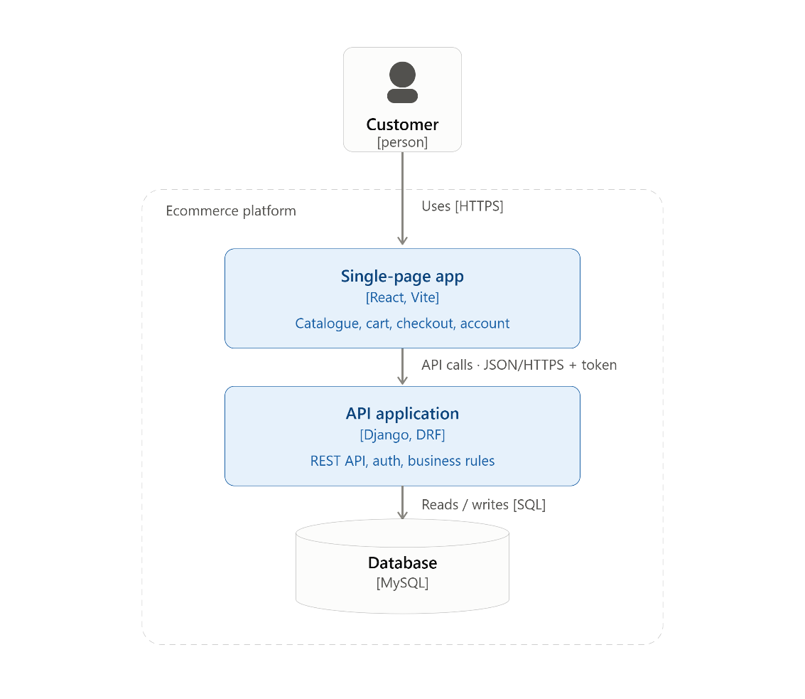
Component diagram
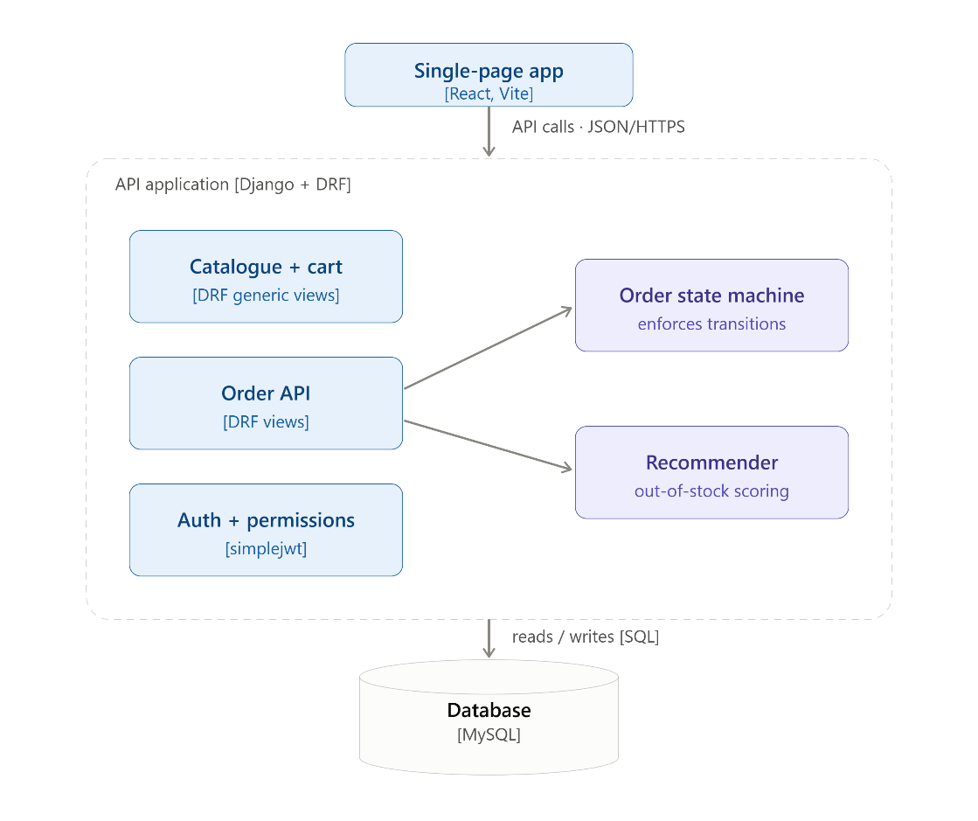
Business flow diagram
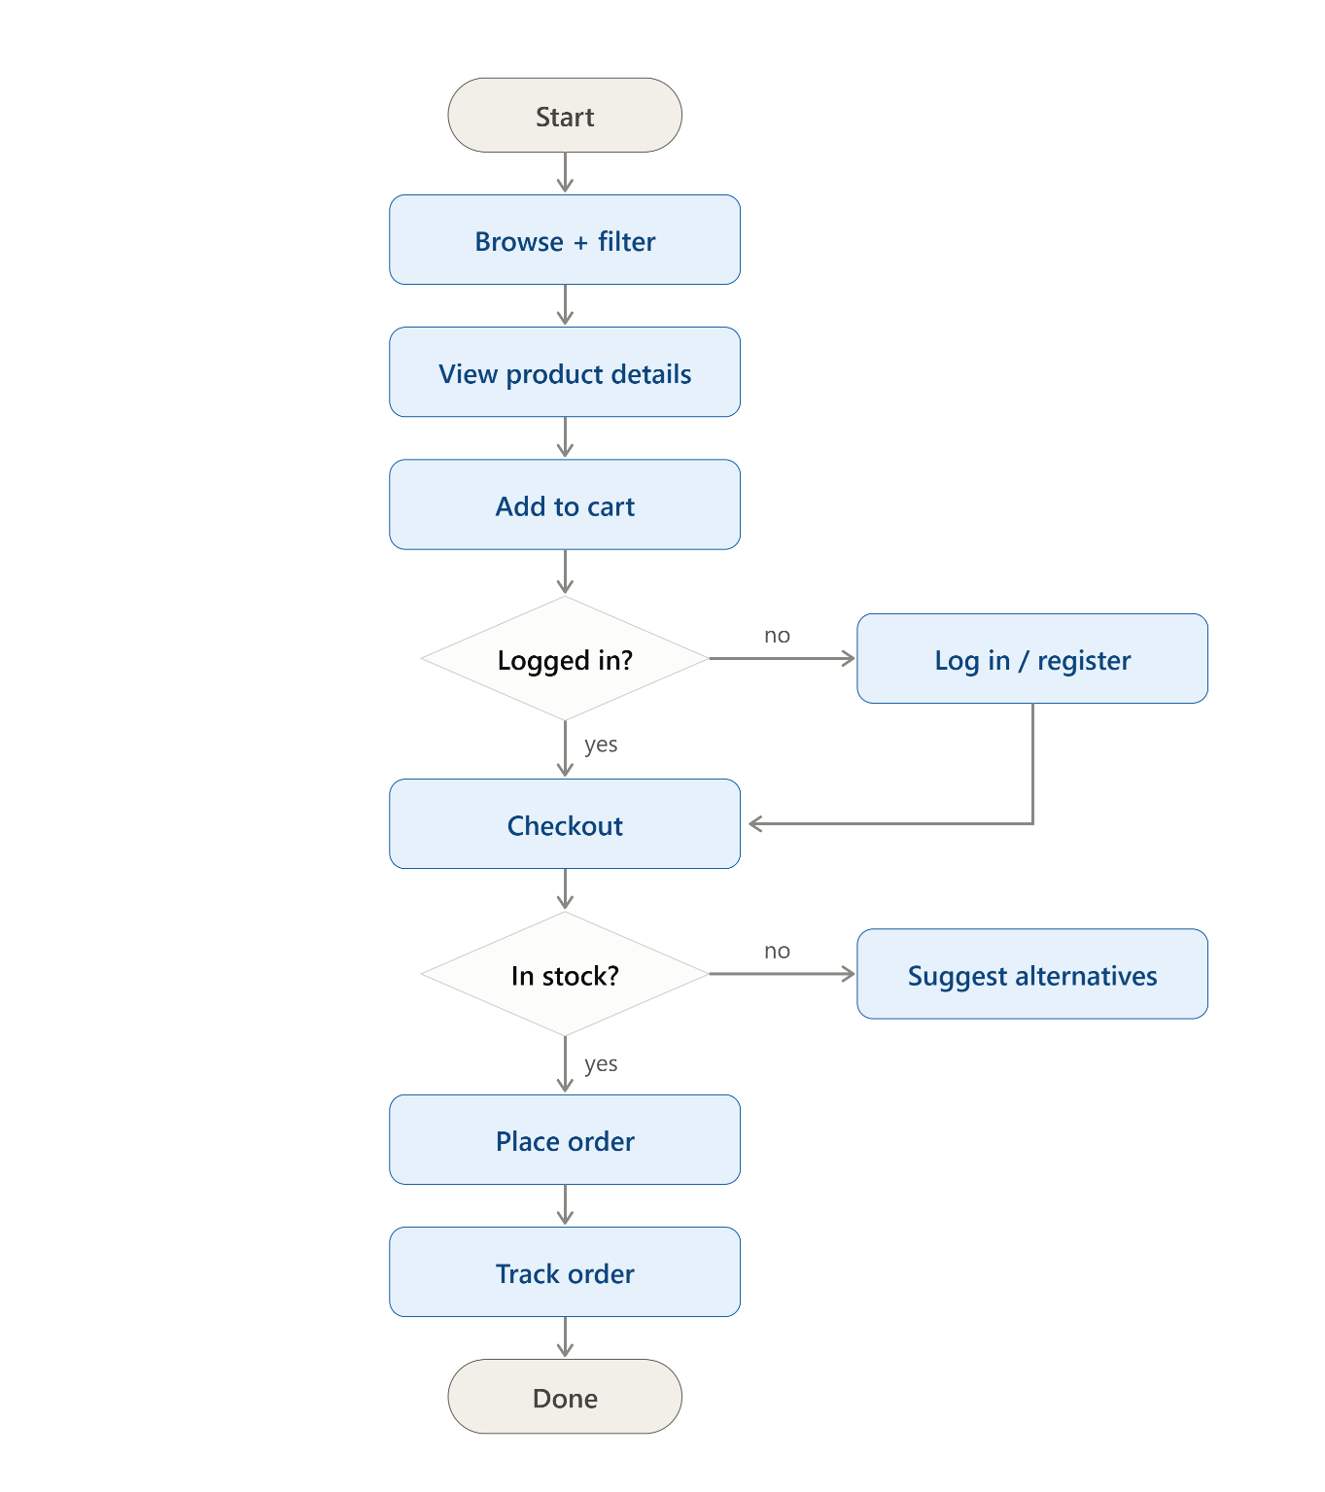

E-R diagram
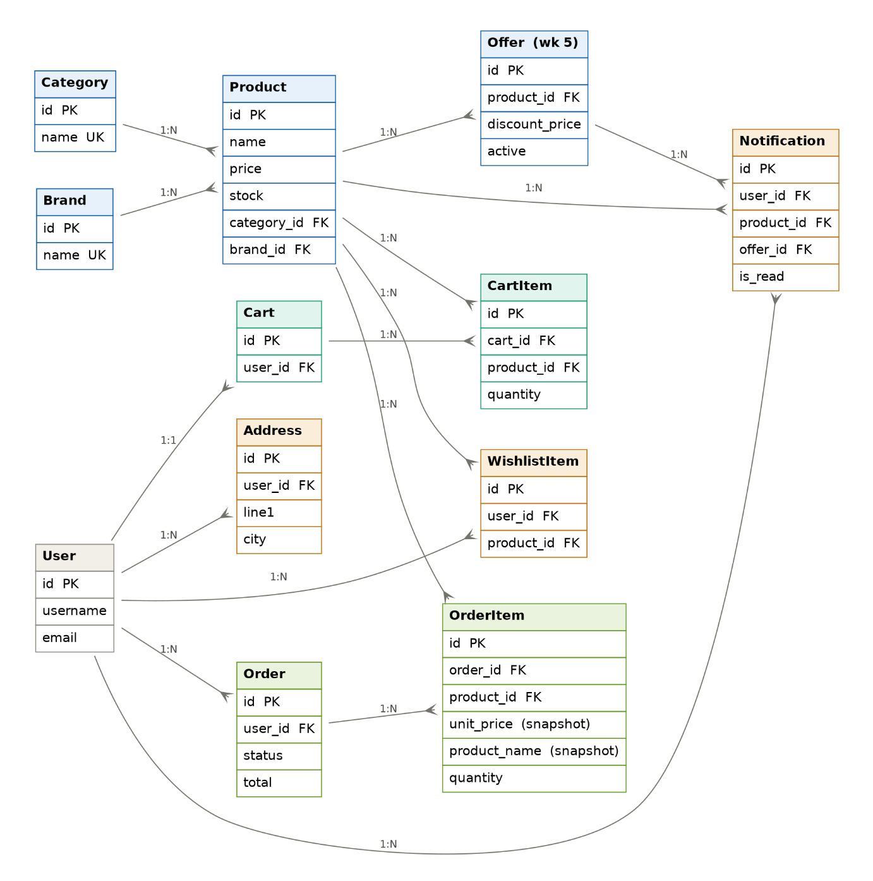

API Design
Method | Endpoint |  |  | Auth |  | Purpose |  | Status
POST |  | /api/register/ | Public |  | Create account |  | Done
POST |  | /api/token/ · /api/token/refresh/ | Public |  | Log in / refresh access token |  | Done
GET |  | /api/products/ | Public |  | List + filter (category, brand, price) |  | Done
GET |  | /api/products/<id>/ | Public |  | Product detail |  | Done
GET |  | /api/categories/ · /api/brands/ | Public |  | Filter dropdown options |  | Done
GET·POST |  | /api/cart/ | User |  | View cart / add item (stock-checked) |  | Done
PATCH·DELETE |  | /api/cart/items/<id>/ | User |  | Update quantity / remove (own cart only) |  | Done
POST |  | /api/orders/ | User |  | Checkout → create order, atomic stock decrement |  | Wk 4
GET |  | /api/orders/ · /api/orders/<id>/ | User |  | List orders / tracking detail |  | Wk 4
PATCH |  | /api/orders/<id>/status/ | Staff |  | State-machine transition (enforced, tested) |  | Wk 4
POST |  | /api/orders/<id>/reorder/ | User |  | Clone an order's items into the cart |  | Wk 4
GET·PATCH |  | /api/profile/ | User |  | View / edit profile |  | Wk 4
GET·POST·DELETE |  | /api/addresses/ · /<id>/ | User |  | Manage saved addresses |  | Wk 4
GET |  | /api/recommendations/?product=<id> | Public |  | Rule-based out-of-stock alternatives |  | Wk 5
GET |  | /api/offers/ | Public |  | Active offers / clearance pricing |  | Wk 5
GET·POST·DELETE |  | /api/wishlist/ · /<id>/ | User |  | Manage wishlist |  | Wk 5
GET·PATCH |  | /api/notifications/ · /<id>/ | User |  | List / mark read (offer alerts) |  | Wk 5
POST |  | /api/chat/ | User |  | Rule-based chatbot over controlled functions |  | Wk 6

